4.8 Centers of Gravity Using Multiple Integrals Worksheet

- A lamina occupies the region . Find the mass and center of mass of the lamina if its density at the point is given by .

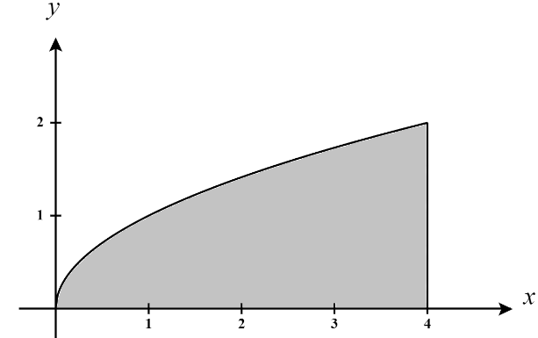
A picture of the region D is:

So, we note that the mass of the lamina is

Then, by definition,

Then, by definition,

Thus, the center of mass of the lamina is .

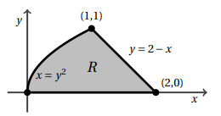
- Consider the region R pictured to the right. Determine the center of mass of this region if the region has a density determined by

We see that we can define R as

So, we note that the mass of the lamina is

Then, by definition,

Then, by definition,

Thus, the center of mass of the lamina is .
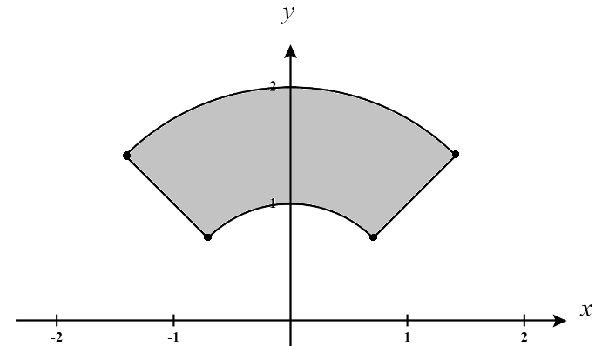
- Consider the region R pictured to the right. Determine the center of mass of this region if the region has a density determined by

We see that we can define R as

So, we note that the mass of the lamina is

Then, by definition,

Then, by definition,
Thus, the center of mass of the lamina is .
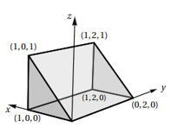
- Consider the solid region E shown to the right. Suppose the density at any point within E is given by . Determine the center of mass of the of E.

We first need to describe the given region. We see that the region is bounded below by 0 and above by the plane . Therefore, we have .

If we project E into the xy-plane we produce a region D defined by .

So, we note that the mass of the lamina is

By definition, we then find that:

Thus, the center of mass of the solid is .

- Let E be the portion of the positive octant which is inside the unit sphere. Determine the center of mass of the E assuming it has a density function .

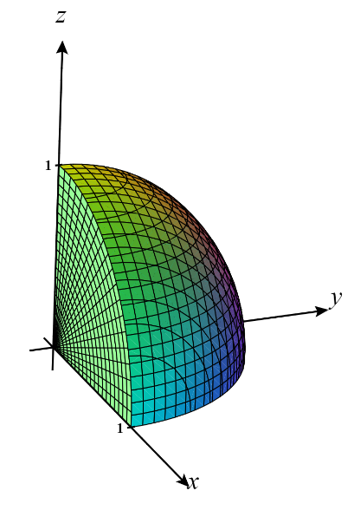
We see that this region is defined by

So, we note that the mass of the lamina is

By definition, we then find that:

Thus, the center of mass of the solid is .
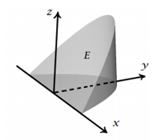
- Consider the region E shown below which is bounded the xy-plane, the plane and the surface . Determine the center of mass of this cone assuming it has a density function .

We first need to describe the region E. We see that the region is bounded below by 0 and above by the plane . Therefore, we have .

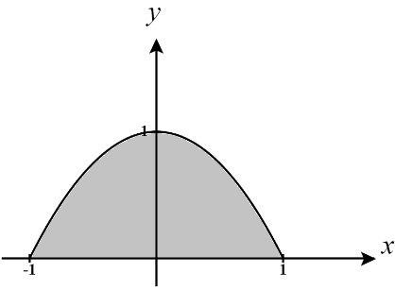
If we project the solid into the xy-plane we produce a region D shown below and can be defined by .

So, we note that the mass of the lamina is

By definition, we then find that:

Thus, the center of mass of the solid is .

